Computer Vision
Mainak Dutta
IRO2017009
Mtech 1st year, Robotics

What are pitfalls doing processing with corners?

We assume for corner detection that we wont get similar pictures with similar features. But it may happen that there are many pictures with different subject but corner at the exact or nearby positions at the picture. So , when we will try to match the images based on the corner feature it may give false positive quite often. This is very difficult problem to solve only by corner detection.
There can be a case of false negative too. If the two pictures are not scaled properly or not aligned with each other. We can get such situations. Maybe the same picture is present as some up scaled or down scaled version or rotated clockwise or anticlockwise , then we wont be able to detect the pic. So a false negative case occurs.
Scaling:

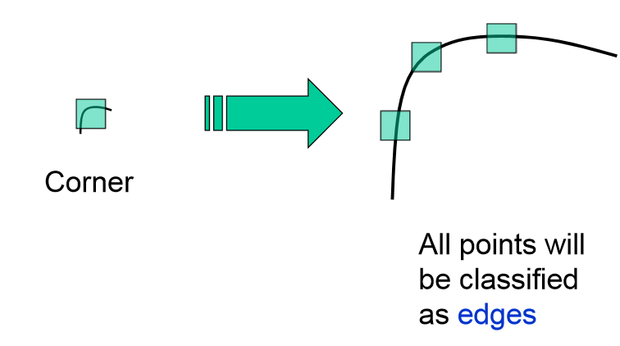

We can clearly see from the picture that corner detector cant manage the scaling.

Affine Normalization:

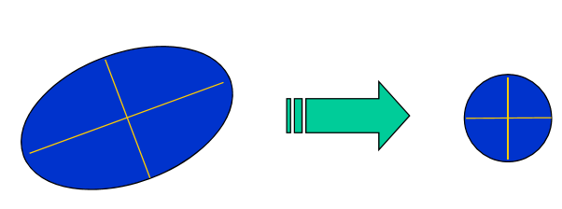

Orientation Ambiguity:
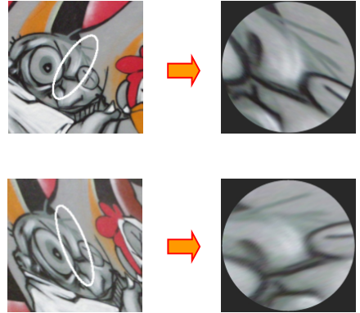

Two supplementary features can be used with corners

- As corner is nothing but joint of two edges , so if we also use edge feature with corner then shape of the object can be easily matched irrespective of the background. It also cant hold scaling.

- We can also use it with blob features. Blob is nothing but Binary Large Objects and it can be used with the corners to detect the image. Blobs are the collection of same pixel values in the close vicinity. As blobs create a collection of similar images it is more reliable than edge detection.

Here we will discuss about the supplementary feature blob with corners.

Blobs are scaling independent and it is very unlikely to have a similar blobs in multiple images or more than one image as compared to the similar corners.
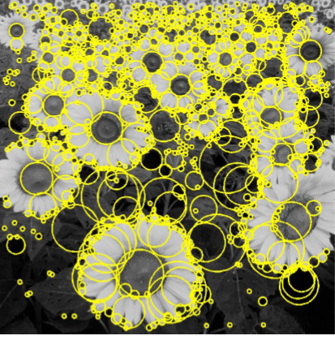
For a similar image with scaled version u will always get same kind of blobs.
Spatial selection: the magnitude of the Laplacian response will achieve a maximum at the center of the blob, provided the scale of the Laplacian is “matched” to the scale of the blob. We want to find the characteristic scale of the blob by convolving it with Laplacians at several scales and looking for the maximum response. The response of a derivative of Gaussian filter to a perfect step edge decreases as σ increases.
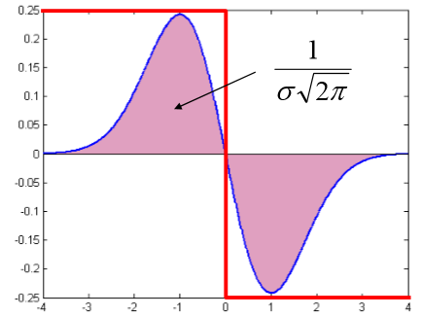

The response of a derivative of Gaussian filter to a perfect step edge decreases as σ increases To keep response the same (scale-invariant), must multiply Gaussian derivative by σ Laplacian is the second Gaussian derivative, so it must be multiplied by σ2.

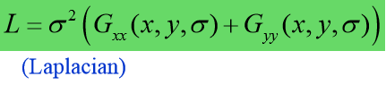
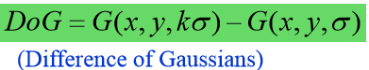
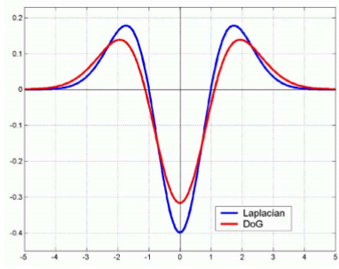

Affine adapted blobs:

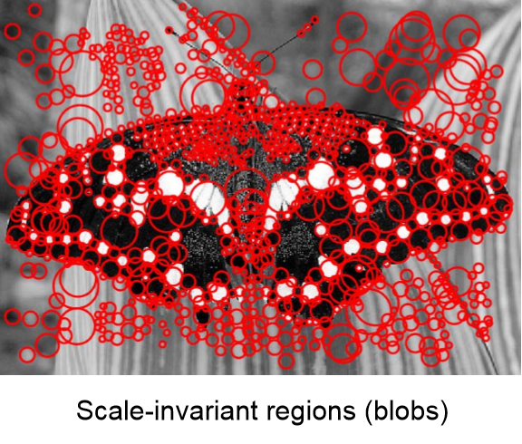
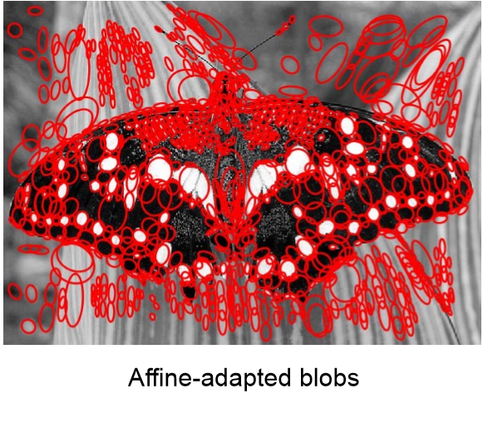

References : Feature Extraction:UNC Computer Science

